Course 7

Tomas Fuenzalida

15 de abril de 2020

library(UsingR)  
library(reshape2)

## Introduction: Basic Least Squares

data(galton); long <- melt(galton)

## No id variables; using all as measure variables

g <- ggplot(long, aes(x = value, fill = variable))  
g <- g + geom_histogram(colour = "black", binwidth = 1)  
g <- g + facet_grid(.~ variable); g

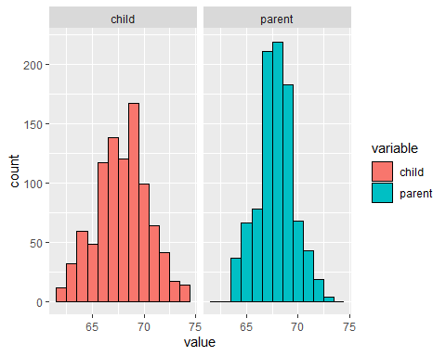

En primer lugar vamos a buscar una forma de precedir la altura de los niños sin ninguna otra informacion, lo mas sensato seria buscar el dato del medio o el promedio, pero como definimos eso. Para definir el medio de un histograma debemos resolver: $\sum_{i=1}^{n}{(}Y_{i}−μ)^{2}$ minimizando $μ$

## Residuals

data("diamond")  
y <- diamond$price; x <- diamond$carat; n <- length(diamond$carat)  
fit <- lm(y ~ x)  
e <- resid(fit) #Residuos (Valor esperado menos valor calculado, Y-Y_i)  
yhat <- predict(fit)  
plot(x,y, xlab = "MASS (carats)", ylab = "Price (SIN $)", bg = "lightblue", col = "black", cex = 1.1, pch = 21)  
abline(fit, lwd = 2)  
for (i in 1:n){  
 lines(c(x[i],x[i]), c(y[i],yhat[i]), col = "red", lwd = 2)  
}

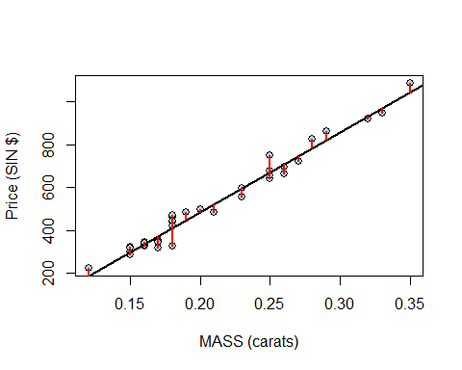

plot(x,e, xlab = "MASS (carats)", ylab = "Residual (SIN $)", bg = "lightblue", col = "black", cex = 1.1, pch = 21)  
abline(h = 0, lwd = 2)  
for (i in 1:n){  
 lines(c(x[i],x[i]), c(e[i],0), col = "red", lwd = 2)  
}

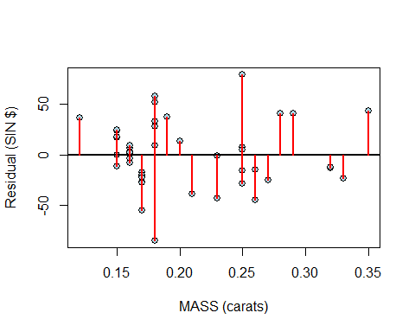

## Intervalo de Confianza

data("mtcars")  
  
fit <- lm(mpg ~ wt, data = mtcars)  
dat <- data.frame(wt = mean(mtcars$wt))  
predict(fit, newdata = dat, interval = "confidence") #Se puede usar prediction tambien (95%)

## fit lwr upr  
## 1 20.09062 18.99098 21.19027

## Multivariable Regression Examples part I

library(GGally); library(ggplot2); library(datasets)

data(swiss); library(GGally); library(ggplot2); library(datasets)  
g = ggpairs(swiss, lower = list(continuous = wrap("smooth", method = "lm")))  
g

